HIGH STEAKS
ACCESS DOCUMENT FOR AUDIENCE MEMBERS
As of 27/09/2023

Hello!

We are so pleased that you are coming to watch one of our performances of HIGH STEAKS. We want to make sure you feel as comfortable as possible seeing the show, so we have put this document together to let you know what to expect. If you haven’t been to a performance like this before, it is normal to have questions about the show and what will happen.

The information in this guide relates to a performance of HIGH STEAKS, of which are not currently BSL interpreted, relaxed or captioned. There will be information about these types of shows separately. None of these will be happening as part of the show for these performances.

We really hope you enjoy the show!

DETAILS
- Run time: 1 hour and 10 mins max
- Age guidance: 18+
- Content warnings: full frontal nudity, strong language, handling and cooking of raw meat, references to self-harm and strong language used throughout
- No video, photography or any documentation of the show/performance is allowed
- Live flame on stage, three candles in a candelabra on the stage
- There might be some audience interaction in the show which could include 1 person coming on stage and drawing Eloina. This is an invitation and you are encouraged to only do this if you would like. There is no pressure!

BEFORE THE SHOW
Venue dependent: there will be a member of our team standing outside or close to the space where the performance is happening, who will be there to greet you and sell merchandise, ahead of the performance. We will be selling temporary tattoos which you will be able to purchase, should you wish, using a card on our iZettle machine which is a singular contactless payment.

The venue staff will be responsible for announcing when the house is open.

When you enter the theatre space, there will be pre-entrance music playing at a moderate volume. Members of the front of house staff will be around to help you find your seat. Once we have clearance from the front of the house at the venue, then the show can begin.

DURING THE SHOW
The lights will go down, the entrance music will be turned off, and the show will begin.

Eloina, the performer in the show, will enter and this will be notified by a spotlight that lights her on stage.

Latecomers will be permitted into the show from any time up until 15 minutes after the show’s start time. Latecomers after 15 minutes will not be admitted.

Throughout the show, sounds will be played at a moderate volume. This includes recorded voice notes/voice overs and songs/music. House lights will not be turned on during the performance meaning there will be spots of blackouts and some dimly lit lighting states of which you will be able to see the performance, and less your surroundings.

AFTER THE SHOW
The end of the performance is marked when Eloina takes a bow on stage.

After this, the lights in the theatre will come back on and everyone will start to leave.

A member of our team will be outside, where they were before, selling merchandise in the same set up as the pre-show.

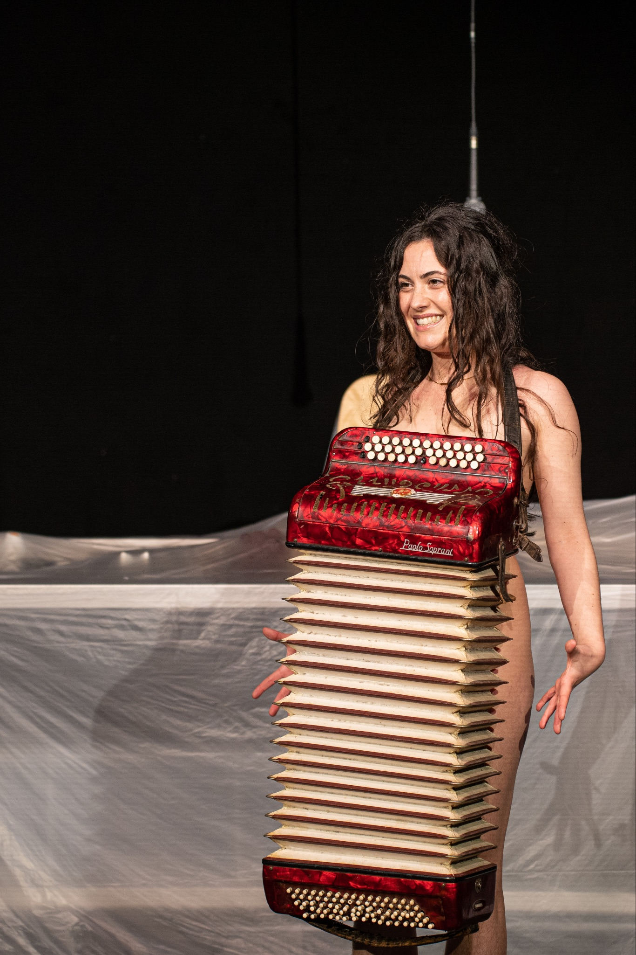
ABOUT ELOINA
ELOINA makes work that dismantles taboos around the female body. She mixes epic, body-based performance art and quick, comedy clowning. This makes her work both accessible and impactful at both extremes and the in-betweens of the art world. Since graduating from the innovative Drama degree at Queen Mary University of London in 2018, her solo practice has spread across London, opening conversations about menstruation, body hair, labiaplasty, vaginoplasty, female masturbation and ejaculation, motherhood and breastfeeding.

VISUALS OF THE SET AND TECHNICAL ASPECTS OF THE SHOW
- End on configuration which involves the audience being completely separate from the actor on stage.
- 4 light pieces of fishing wire with pegs connected, hanging from the theatre ceiling/rig

The above image is a photo of the set up: this is how the show will look

The above image is the layout of everything that is on stage
If you have any questions, please endeavor to contact a member of the team, Millie (she/her) or Beth (she/they) who are the producers of HIGH STEAKS on producer@eloina.art

Thank you and we hope you enjoy the show!

